# **جامعة الزقازيق**



# **كلية الهندسة**

# **الفرقة الأولى قسم الهندسة الكهربية**

**“Railway Reservation System”**

|  |  |
| --- | --- |
|  | اسم الطالب |
|  | رقم الجلوس |
|  | الايميل |

**Abstract**

With c programming language I will design a program for Railway reservation tickets for passenger. In this program I will use many functions and methods. This program will ask user(passenger) for his name, address, and his money for booking a ticket. In this program we should insertion train information such as number of trains, time of trip, destination of train, and cost of this trip.

I will use array for storing mane passengers and add many trains not only one. I will use structure for save much data in one variable. In this program will be there main function (oid passwordfunction(), void mainmenufunction(), void trips(), void addpassenger(), void reservationtickets(), void modifytrain()).

Main function in this program will be:

1. **Insertion of the trip’s information**: train number, destination, time, cost.
2. **Insertion of the passenger data**: name, address, credit (money the passenger must pay for trips each time).
3. **Reservation of a trip**: by entering the destination and print the suitable trip according to time and then subtract the cost of trip of the credit of passenger and then print all information of the trip ( train number, destination, time, cost, passenger name).
4. **Modify**: a certain trip information by entering train number and receive the new data (destination, time, cost).

**Introduction**

1. Flow chart of the program:

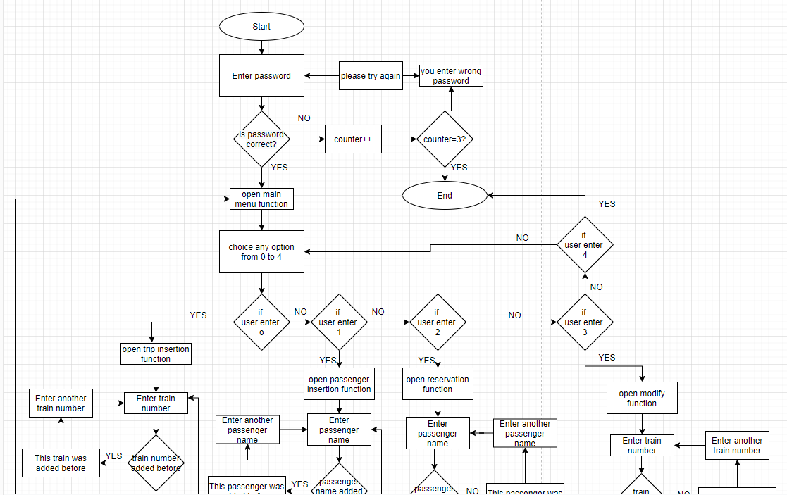

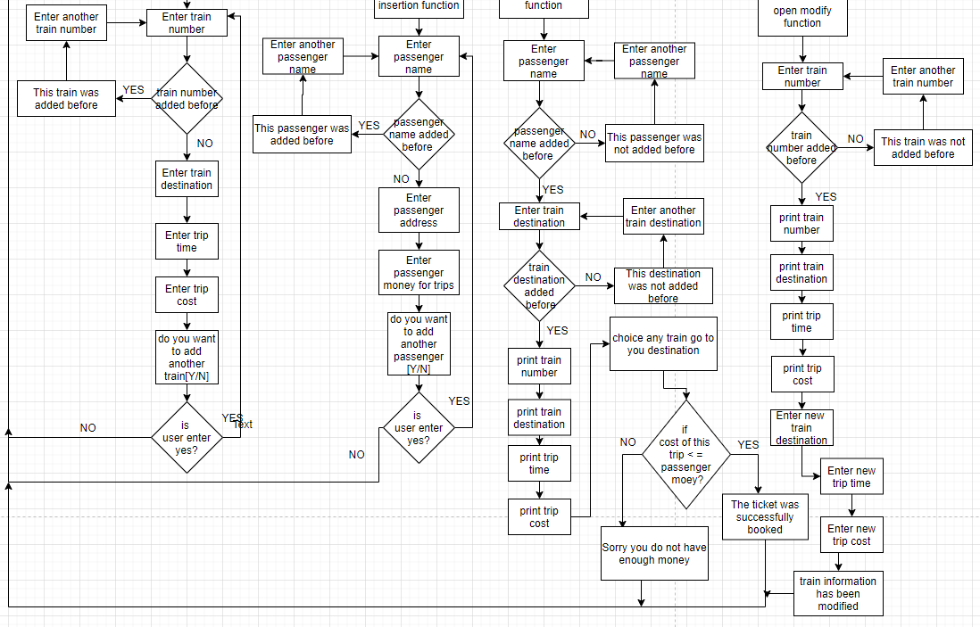

1. Explain program functions:
   1. **void passwordfunction():** Function For Check The Password For ThreeTimes.in this function a general variable has been defined that holds the password and when the program started a variable of the same type as the general variable is created and the user is asked to enter the password and through a calculation (subtraction) the program compares the password the user entered with the first command password and if it is correct the program moves To the main menu, and if it is not correct, an error message is shown to the user in order to try again, and at this moment another general variable increase +1, and when this variable reaches three (i.e. its value is equal to 3) an error message is shown to the user and the program is exited and I have used nested if() function for this process. First if() for check if the password is correct or not. Second if() for checking if the counter reached to 3 or not.
   2. **void mainmenufunction():** function for main menu. In this function the screen is cleared at the beginning and then some addresses are appearing on the screen window such as (Railway Reservation System, [0] Insertion of trips information, [1] Insertion of passenger data, [2] Reservation of trips, [3] Modify a trip information, [4] Exit). These addresses are options which user can choice one of them. These options have numbers from 0 to 4. Then a variable of the integer type is created. At the bottom of the screen is the phrase (choice any option) and is waiting for the user to enter a number to store in the variable that was created and if an error number or anything else is entered, an error message appears and the program requests the user to press any button to return to main menu again. And if a valid number is entered, the user is directed to the window whose address has the same number and I used that function if() for this process.
   3. **void trips():** Function for insertion of trips information. In this function, the screen is cleared at the beginning. A variable of the character type is created and then the user is asked to enter the train number to be stored in this variable so if this number is already present then a message appears to the user to inform him about that and then ask him to press any key to try again and enter another train number and if he did not exist before this number is stored in the train number For the train data then a message appears to enter the destination and then the time and then after cost of this trip. When finished, a message appears to the user (Train information has been added:)) and then a message appears to inform the user whether he wants to enter the data of a new train or return to the main menu.
   4. **void addpassenger():** This function is very similar to the previous one, it stores the passenger information. the user is asked to enter the passenger name to be stored in character variable so if this name is already present then a message appears to the user to inform him about that and then ask him to press any key to try again and enter another name and if he did not exist before this name is stored in the passenger name For the passenger data then a message appears to enter the address and then after money the passenger must pay for trips each time. When finished, a message appears to the user (passenger data has been added:)) and then a message appears to inform the user whether he wants to enter the data of a new passenger or return to the main menu.
   5. **void reservationtickets():** In this function, the screen is cleared at the beginning. Two variable of the character type are created, the user is asked to enter the passenger name to be stored in one of character variable so if this name is not present then a message appears to the user to inform him about that and then ask him to press any key to try again and enter another name and if he existed before, the user is asked to enter the his destination to be stored in the second variable so if there is not any train will go to this destination a message appears to the user to inform him about that and then ask him to press any key to try again and enter another destination and if there is train will go to this destination. Program will print all information of this trains (train number, destination, time, cost). then a message appears to the passenger for choosing his train. If the cost of this train [price of ticket] was greater than the passenger money a message appears to tell the user [sorry you do not have enough money for this trip:(] and program return to main menu. Else if the cost of this train [price of ticket] was less than the passenger money, program print all information of the trip (train number, destination, time, cost, passenger name).
   6. **void modifytrain():** Function for modifying information of train. In this function, the screen is cleared at the beginning. A variable of the character type is created and then the user is asked to enter the train number to be stored in this variable so if this number is not exist a message appears to the user to inform him about that and then ask him to press any key to try again and enter another train number and if the train number exist before, program print all information of this train (destination, time, cost). And asked the user to enter the new information of this train (destination, time, cost). After finishing the program return to main menu.

**Results**

|  |
| --- |
| The code |
| #include <stdio.h>  #include <stdlib.h>  #include<string.h>  /*********this variables are global******/  int passwordkey=4321;counter1=0;counter2=0,counter3=0;  /*********function for animation[load screen]************/  void loadtime(int t){  int t1,t2;  for(t1=0;t1<t;t1++){  t2=t1;  }  }  /********structure for storing data of trains*************/  struct traindata{  char destination[50],trainnumber[30];  float triptime,cost;  }; struct traindata t[200];  /*********structure for storing data of passengers*************/  struct passengers{  char name[30],address[30];  float balance;  }; struct passengers p[1000];  /**************password function[this function for security of the program]****/  void passwordfunction(){  system("CLS");  int ps;  printf("\n\t\t\t\tEnter password please: ");  scanf("%d",&ps);  /****check if the password is correct or not*************/  if(ps!=passwordkey){  /******check if the user enter the password for three times or not**********/  if(counter1<2){  printf("\n checking password");  for(int t=0;t<=50;t++){  loadtime(9999999);  printf(".");  }  /*********if the user enter wrong password************/  counter1++;  printf("\n\t\t\t\tWrong password press any key to try again");  getch();  passwordfunction();  }  /********if the user enter the wrong password for three times***********/  else{  printf("\n checking password");  for(int t=0;t<=50;t++){  loadtime(9999999);  printf(".");  }  system("CLS");  printf("\n\n\t\t\t\tyou enter the wrong password for three times\n\n");  exit(0);  }  }  /***********if the user enter the correct password***********/  else {  printf("\n\ checking password");  for(int t=0;t<=50;t++){  loadtime(9999999);  printf(".");  }  mainmenufunction();  }  }  /*************main menu function[this function for showing all options**************/  void mainmenufunction(){  system("CLS");  int m;  do{  system("CLS");  printf("\n\t\t\t\t*** Railway Reservation System ***\n");  printf("\n\n\t\t\t\t[0] Insertion of trips information");  printf("\n\n\t\t\t\t[1] Insertion of passenger data");  printf("\n\n\t\t\t\t[2] Reservation of trips");  printf("\n\n\t\t\t\t[3] Modify a trip information");  printf("\n\n\t\t\t\t[4] Exit");  printf("\n\n\t\t\t\tChoice any option: ");  scanf("%d",&m);  if(m==4)exit(0);  else if(m==0)trips();  else if(m==1)addpassenger();  else if(m==2)reservationtickets();  else if(m==3){  system("CLS");  int s;  printf("\n\t\t\t\tEnter password: ");  scanf("%d",&s);  if(s==passwordkey)modifytrain();  else{  printf("\n\t\t\t\tWrong password:(");  printf("\npress any key to return to main menu");  getch();  mainmenufunction();  }  }  }while(m>4);  }  /***********function for insertion of trips information************/  void trips(){  system("CLS");  char n,number[30];  printf("\n\t\t\t\t*** Insertion of trips information ***\n");  printf("\n\n\t\t\t\tenter train number: ");  scanf("%s",number);  for(int x=0;x<=counter2;x++){  /*******check if the train was added before or not*************/  if(strcmp(number,t[x].trainnumber)==0){  printf("\n\t\t\t\tThis train was added before");  printf("\nPress any key to try again");  getch();  trips();  }  }  strcpy(t[counter2].trainnumber,number);  printf("\n\t\t\t\tEnter train destination: ");  scanf("%s",t[counter2].destination);  printf("\n\t\t\t\tEnter trip time[24 hour]: ");  /*****time with 24 hour***********/  scanf("%f",&t[counter2].triptime);  while(t[counter2].triptime>25){  printf("\n\t\t\t\tEnter time from 1h to 24h only: ");  scanf("%f",&t[counter2].triptime);  }  printf("\n\t\t\t\tEnter trip cost: ");  scanf("%f",&t[counter2].cost);  counter2=counter2+1;  printf("\n Loading");  for(int t=0;t<=50;t++){  loadtime(9999999);  printf(".");  }  printf("\n\n\t\t\t\tTrain information has been added:)");  /******to choice if the user want to add new train or not***********/  printf("\n\nDo you want to add another train[Y/N]: ");  fflush(stdin);  scanf("%c",&n);  switch(n){  case 'y':trips();  break;  default:mainmenufunction();  }  }  /*******function for insertion of data of passengers**************/  void addpassenger(){  system("CLS");  char n, pn[30];  printf("\n\t\t\t\t*** Insertion of passenger data ***");  printf("\n\n\n\t\t\t\tEnter passenger name: ");  scanf("%s",pn);  for(int i=0;i<=counter3;i++){  /*******check if this passenger was added before or not***********/  if(strcmp(pn,p[i].name)==0){  printf("\n\t\t\t\tThis passenger name was added before");  printf("\nPress any key to try again");  getch();  addpassenger();  }  }  strcpy(p[counter3].name,pn);  printf("\n\t\t\t\tEnter passenger address: ");  scanf("%s",p[counter3].address);  printf("\n\t\t\t\tEnter money the passenger have to pay: ");  scanf("%f",&p[counter3].balance);  counter3=counter3+1;  printf("\n Loading");  for(int t=0;t<=50;t++){  loadtime(9999999);  printf(".");  }  printf("\n\n\t\t\t\tpassenger data has been added:)");  /******to choice if the user want to add new passenger or not***********/  printf("\n\nDo you want to add another train[Y/N]: ");  fflush(stdin);  scanf("%c",&n);  switch(n){  case 'y':addpassenger();  break;  default:mainmenufunction();  }  }  /***********this function for reservation tickets for trips****************/  void reservationtickets(){  system("CLS");  int a=0;  char n,pn[30],dest[50],number[30];  printf("\n\t\t\t\t*** Reservation of trips ***");  printf("\n\n\n\t\t\t\tEnter passenger name: ");  scanf("%s",pn);  for(int x=0;x<=counter3;x++){  /*******check if this passenger was added before or not***********/  if(strcmp(pn,p[x].name)==0){  printf("\n\t\t\t\tenter your destination: ");  scanf("%s",dest);  while(a==0){  printf("\n Loading");  for(int t=0;t<=50;t++){  loadtime(9999999);  printf(".");  }  printf("\n\n\t\t\t\tTrain number\tdestination\tcost\t\ttrip time\n\t\t\t");  for(int i=0;i<=80;i++){  printf("=");  }  for(int y=0;y<=counter2;y++){  /*******check if this destination was added before or not*************/  if(strcmp(dest,t[y].destination)==0){  printf("\n\t\t\t\t %s\t\t%s\t\t%.3f$\t\t%2.3f",t[y].trainnumber,t[y].destination,t[y].cost,t[y].triptime);  a=1;  }  }  if(a==0){  printf("\n\t\tSorry,we do not have any train going to this destination right now:(");  printf("\n\n\t\t\t\tplease enter another destination: ");  scanf("%s",dest);  }  }  printf("\n\n\t\t\t\tchoice any train[enter number of train]: ");  scanf("%s",number);  for(int z=0;z<=counter2;z++){  if(strcmp(number,t[z].trainnumber)==0){  /******check if the passenger have enough money or not*************/  if(t[z].cost<=p[x].balance){  p[x].balance=p[x].balance-t[z].cost;  printf("\n\t\t\t\tpassenger name is: %s",p[x].name);  printf("\n\t\t\t\tpassenger money is: %f$",p[x].balance);  printf("\n\t\t\t\ttrain number is: %s",t[z].trainnumber);  printf("\n\t\t\t\tdestination is: %s",t[z].destination);  printf("\n\t\t\t\tcost of this trip is: %.3f$",t[z].cost);  printf("\n\n\t\t\t\tThe ticket was successfully booked:)");  printf("\n\npress any key to return to main menu");  getch();  mainmenufunction();  }  /********if passenger does not have enough money*********/  else{  printf("\n\t\t\t\tsorry you do not have enough money for this trip:(");  printf("\npress any key to return to main menu");  getch();  mainmenufunction();  }  }  }  }  }  /**********if passenger name not exist***********/  printf("\n\t\t\t\tThis passenger was not added before");  printf("\npress any key to try again");  getch();  reservationtickets();  }  /***************this function for modifying train data**********/  void modifytrain(){  system("CLS");  char number[30];  printf("\n\t\t\t\t*** Modify a trip information ***");  printf("\n\n\n\t\t\t\tEnter train number: ");  scanf("%s",number);  for(int m=0;m<=counter2;m++){  /********check if this train was added before or not***********/  if(strcmp(number,t[m].trainnumber)==0){  printf("\n Loading");  for(int t=0;t<=50;t++){  loadtime(9999999);  printf(".");  }  printf("\n\n\t\t\t\tTrain number\tdestination\tcost\t\ttrip time\n\t\t\t");  for(int i=0;i<=80;i++){  printf("=");  }  printf("\n\t\t\t\t %s\t\t%s\t\t%.3f$\t\t%2.2f",t[m].trainnumber,t[m].destination,t[m].cost,t[m].triptime);  printf("\n\n\t\t\t\tEnter new train destination: ");  scanf("%s",t[m].destination);  printf("\n\t\t\t\tEnter trip time[24 hour]: ");  /*****time with 24 hour***********/  scanf("%f",&t[m].triptime);  while(t[m].triptime>25){  printf("\n\t\t\t\tEnter time from 1h to 24h only: ");  scanf("%f",&t[m].triptime);  }  printf("\n\t\t\t\tEnter trip cost: ");  scanf("%f",&t[m].cost);  printf("\n Loading");  for(int t=0;t<=50;t++){  loadtime(9999999);  printf(".");  }  printf("\n\n\t\t\t\tTrain information has been modified:)");  printf("\npress any key to return to main menu");  getch();  mainmenufunction();  }  }  printf("\n\t\t\t\tThis train was not added before");  printf("\nPress any key to try again");  getch();  trips();  }  int main()  {  passwordfunction();  } |

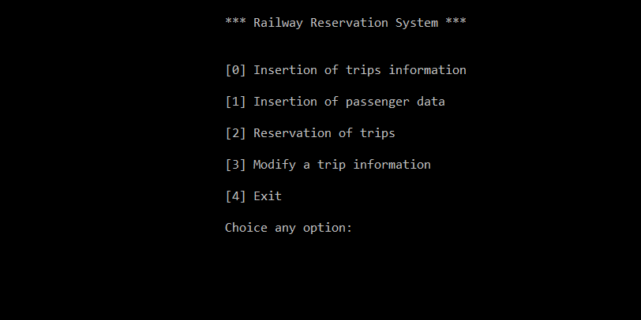

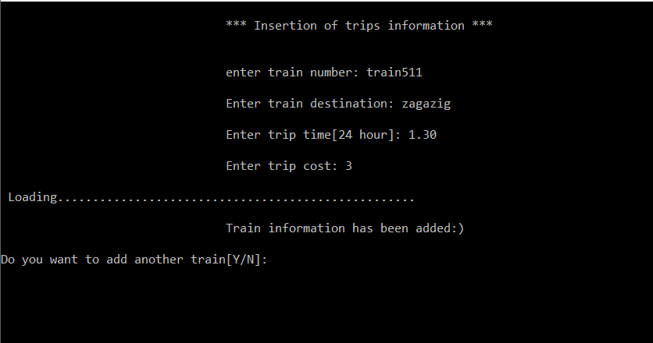

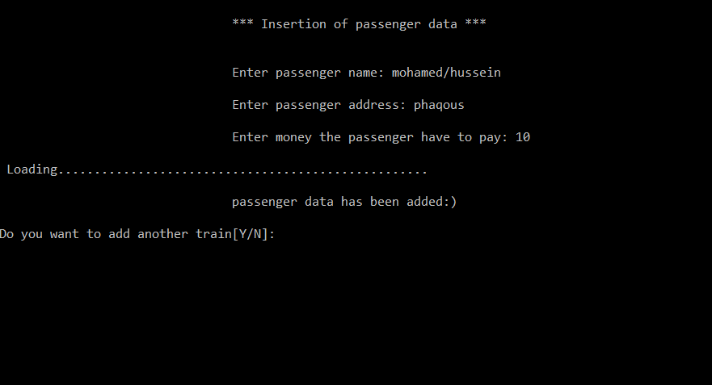

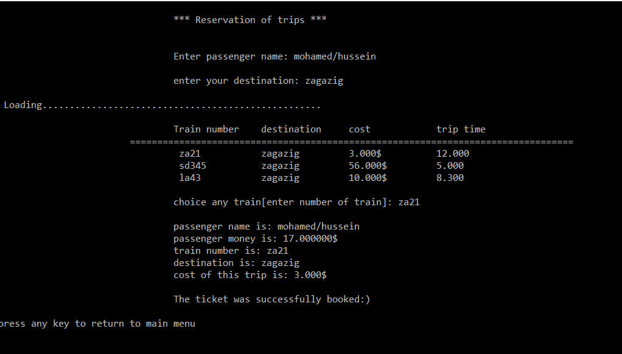

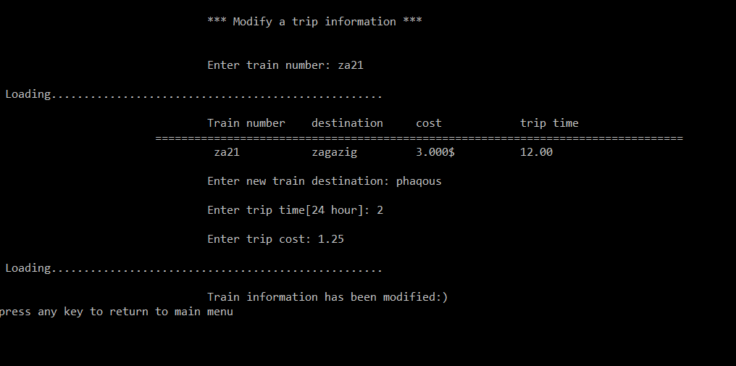

**Discussion**

**1. void passwordfunction():** in this function user should enter password and the program check if it corrects or not by comparing it with the correct password and if it was wrong counter increase by one. If the counter reach to three the program exits else if the password is correct the program opens the main menu.

|  |  |
| --- | --- |
| variables | Explain |
| Passwordkey=4321; | Variable from integer type. This variable holds the password. |
| Counter1=0; | Variable from integer type. This variable calculates number of times which the user enters the incorrect password. If it values equal three the program exit |

|  |  |
| --- | --- |
| Functions | Explain |
| if(ps!=passwordkey){ } | Check if the user enters the correct password or not |
| if(counter1<2){ } | Check if the counter value equal three or not |
| exit(0); | To leave the program |

**2.void reservationtickets() :** this function allows to user to book a ticket. First, the user should enter his name and enter his destination. Second, the user should choice any train will go to this destination. If the cost of this trip was greater than the passenger money ticket not booked successfully. Else if the cost if this trip was less than the passenger money the program subtracts this cost from passenger money and book the ticket.

|  |  |
| --- | --- |
| variables | Explain |
| pn[30] | Variable from character array[string] type. This variable receives from the user the name of passenger. |
| dest[50] | Variable from character array[string] type. This variable receives from the user the destination of passenger. |
| counter3 | Variable from integer type. This variable holds the number of passengers |
| counter2 | Variable from integer type. This variable holds the number of trains |

|  |  |
| --- | --- |
| Functions | Explain |
| for(int x=0;x<=counter3;x++){ } | This function search on all records of passenger about name of this passenger. |
| if(strcmp(pn,p[x].name)==0){ } | This function check if this name was found or not[added before or not exist] |
| for(int y=0;y<=counter2;y++){ } | This function search on all records of trains about destination. |
| if(strcmp(dest,t[y].destination)==0){ } | This function check if there are any train will go to this destination or [destination before or not exist] |

1. in this program we used array and structure, array for make many places in the memory from one variable type this method allow us to add many passengers and trains in the program. Structure for store different and many variables in one variable, because structure is  a composite data type (or record) declaration that defines a physically grouped list of variables under one name in a block of memory, allowing the different variables to be accessed via a single pointer or by the struct declared name which returns the same address. The struct data type can contain other data types so is used for mixed-data-type records.

**Conclusion**

In the end, this program simulates the process in any station. This program makes many processes such as add new passenger, Insertion of the trip’s information, and book a ticket. One of the advantages of this program is that a function has been done for every purpose and then calling these functions in the appropriate way in the main function and also general and not local variables have been created so that it can be passed to all functions easily. This program and the program like it are a data base program because it can save data.in the end I say that this program run without errors. And it is easy to use.

**References**

[1] I have used this site for flow char (https://app.diagrams.net/)

[2] I have used this site for this function [system("color 17");] (https://www.programmingsimplified.com/c/graphics.h/colors )

[3] I have used this site for this function[ struct]

(https://devdocs.io/c/language/struct)

[4] I have used this site for this function[ fflush[stdin]

(<https://devdocs.io/c/io/fflush>)

[5] <https://en.wikipedia.org/wiki/Struct_(C_programming_language)>